**Basic Electronics**

**Assignment # 3**

**Section: A21 Due Date: 8-2-22**

**Total Marks: 20 (15+5)**

1. Consider the center-tapped rectifier shown in Fig-1 and answer the following questions
2. What is the total peak secondary voltage?
3. Find the peak voltage across each half of the secondary.
4. Sketch the voltage waveform across *RL.*
5. What is the peak current through each diode?
6. What is the PIV for each diode?

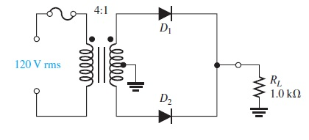

Fig-1

1. Draw the output voltage waveform of the following bridge rectifier

